Week 1

**Installation and Abstract Writing**

1. Installation of Docker

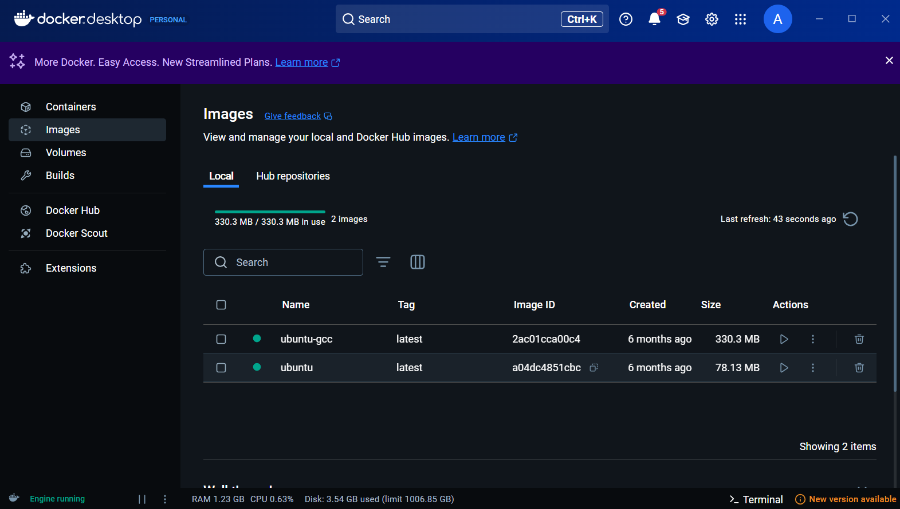

1. Installation of Star UML

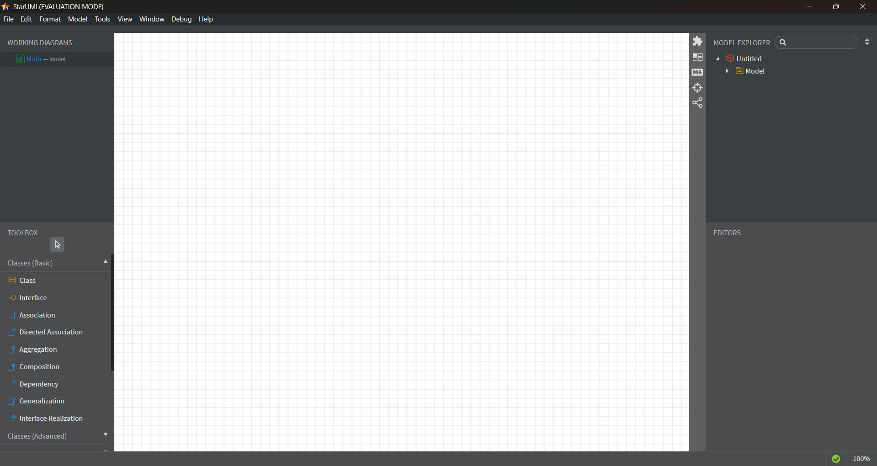

1. Git Bash

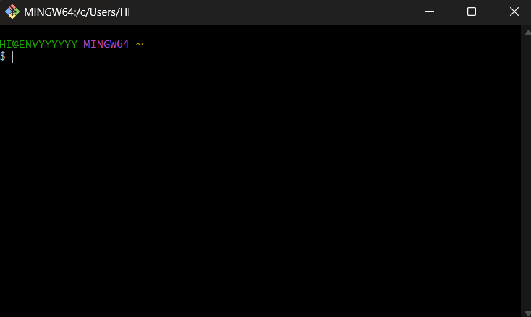

1. Docker Hub

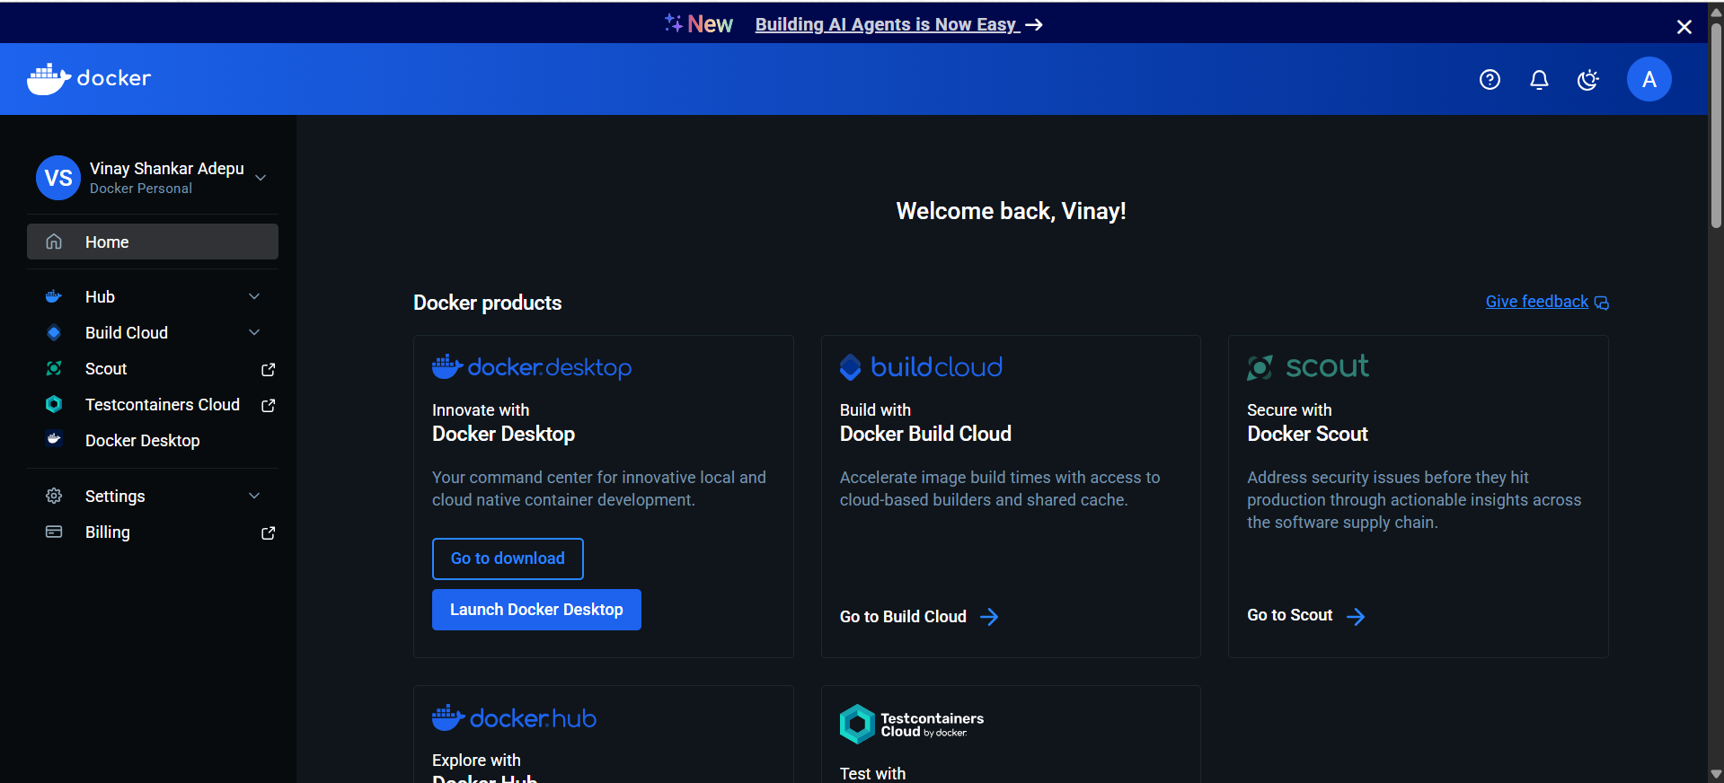

1. Git Hub

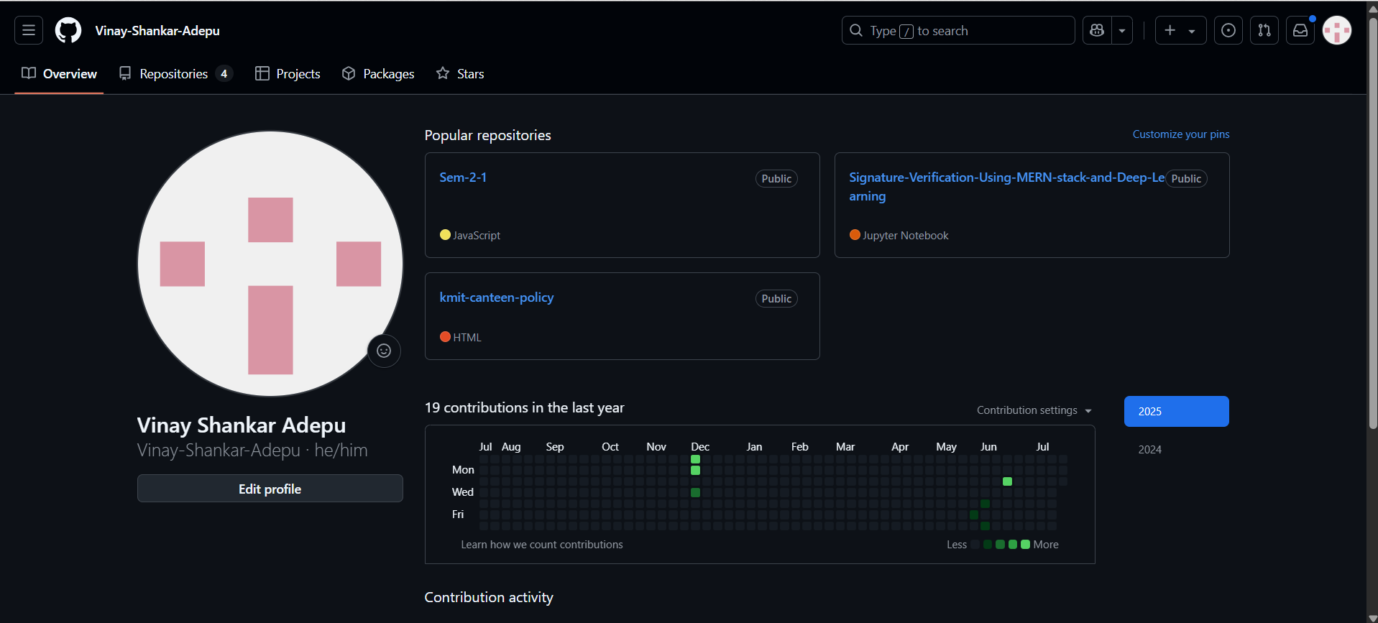

1. Checking Version Controls

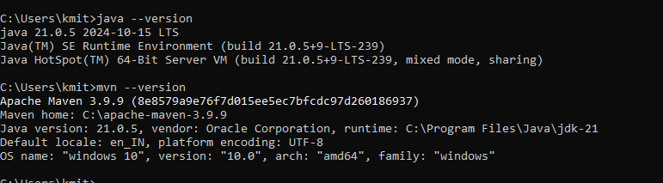

1. Tom Cat

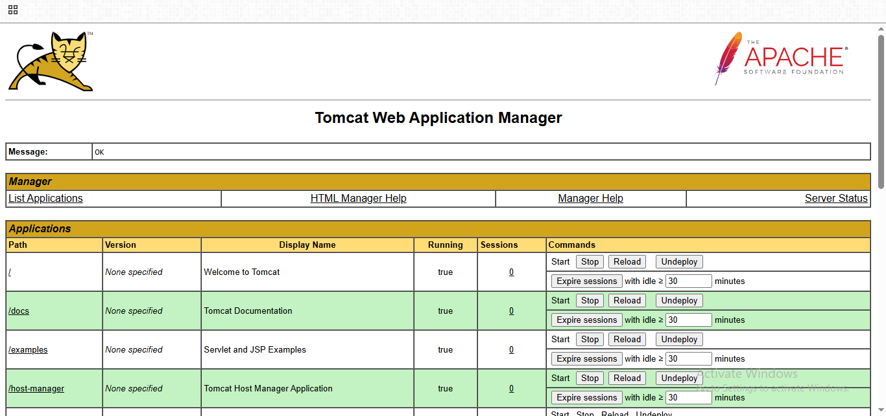

**Spotify Abstract Writing:**

Spotify is a popular app that allows people to listen to millions of songs and podcasts online anytime without needing to download them. It helps users easily find songs, create and share playlists, and receive personalized music suggestions based on their mood. The app streams music directly over the internet, using advanced computer programs designed to support many users simultaneously without issues. Studying Spotify in software engineering is valuable because it demonstrates how software can be built to handle large user bases, deliver customized content, and provide fast, seamless access to music. Overall, Spotify combines smart technology with a simple design to make enjoying music easy and accessible anywhere.

**FixItNow Abstract Writing:**

FixItNow – All Services at One Place is a responsive web-based platform developed using HTML, CSS, and JavaScript to simplify the process of hiring local home service professionals. The system connects users with skilled service providers such as electricians, plumbers, carpenters, and appliance repair technicians based on their location and real-time availability.

The application offers seamless user interaction through an intuitive interface and enables key functionalities such as user and provider registration, service browsing, job booking, availability updates, and live job status tracking. The backend is powered by Firebase Firestore, which provides real-time database capabilities, secure authentication, and cloud-hosted data storage, reducing the need for complex server-side management.

FixItNow ensures a streamlined experience for both customers and service providers by offering role-based access, asynchronous job handling, and mobile-friendly design. The platform addresses common challenges in traditional service booking—such as delays, lack of visibility, and miscommunication—by offering a centralized and automated solution.

The project emphasizes scalability, reliability, and user convenience, making it a modern and efficient approach to managing everyday service needs in a digital-first environment.